August 10, 2020

Dear Kansas City OCR ([OCR.KansasCity@ed.gov](mailto:OCR.KansasCity@ed.gov)):

The University of Oklahoma (University) is required to enforce Title IX’s prohibition of sex discrimination, including sex discrimination against males as a condition of receiving federal (taxpayer) financial assistance. And yet the University illegally discriminates on the basis of sex for multiple single-sex, female-only programs in the Women in Engineering (WiE) program that are offered exclusively for female students while illegally excluding male students. Details on those discriminatory programs are provided below.

1. The mission of the [Women in Engineering (WiE) program](https://www.ou.edu/coe/student_life/wie/events) at The University of Oklahoma (OU), as the program name indicates is a single-sex, female-only program “to inspire and foster the advancement and achievement of **women** **[but not men]** in engineering and sciences.” The stated mission of the WiE is a mission that applies exclusively to female students while illegally excluding men, whose academic advancement and achievement is not considered or valued by the University. Further, the University does not offer an equivalent male-only “Men in Engineering” program that would fairly and equitably accommodate male students with the same educational resources that are currently offered exclusively to female students.

The WiE program offers, operates, funds, and hosts a number of single-sex, female-only programs that illegally and exclusively serve female students while excluding and discriminating against male students based on their sex as multiple gender-specific female references in the program descriptions verify, including:

2. The mission of the University’s [GLAMS (Girls Learning and Applying Math and Science) Program](https://www.ou.edu/coe/student_life/wie/events/glams) is “to introduce **middle school girls [only]** to science, technology, engineering and mathematics (STEM) and to encourage them to explore STEM concepts through fun, hands-on design projects led by current students in the University of Oklahoma (OU) Gallogly College of Engineering (GCoE) and the Mewbourne College of Earth and Energy (MCEE).” GLAMS is held annually on the OU campus and hosts approximately **one hundred female students in 6th – 8th grade**, **but ZERO boys**.

At the Event Details link: WHO: **Girls [but not boys] in their 6th, 7th, or 8th-grade yea**r in the spring of this academic year should apply.

In violation of Title IX, the GLAMS program illegally discriminates against 6th, 7th, and 8th-grade boys who are illegally excluded from participation in this program.

3. [BP Women Mentoring Women](https://issuu.com/wie0000/docs/wie_brochure) as the program name indicates is a single-sex, female-only program that “helps **freshman and transfer women [but not men]** transition and persist in engineering and sciences through peer-to-peer mentorship.” In violation of Title IX, this program is offered exclusively for female students and illegally excludes and discriminates against male students based on their sex. There is no male-only equivalent “BP Men Mentoring Program” offered by the University to legally and fairly accommodate male students with the same educational benefits that the University now offers exclusively for women.

4. The mission of the University’s discriminatory [Chevron Sponsor Series](https://www.ou.edu/content/dam/CoE/wie/docs/sponsors/wie-sponsor-series-chevron.pdf) is “to inform and inspire **current female [but not male] students** in the University of Oklahoma Gallogly and Mewbourne colleges through the elucidation of the diversity of opportunity related to positively impacting society through academic and professional pursuits. This WiE Sponsor Series edition highlights a current WiE sponsor, Chevron.” In violation of Title IX, male students are illegally excluded from participating in this educational program that the University offers exclusively for female students.

5. The University’s [Halliburton Women in Engineering Retreat](https://www.ou.edu/coe/student_life/wie/events/halliburton-women-in-engineering-retreat) as the name indicates is a single-sex, female-only program whose stated mission is “to create an environment for our **women engineering students** to empower one another, take time for self-exploration, and reflection for personal growth and an enriching, meaningful experience.” A recent photo below of the retreat participants verifies that 100% of the participants in this program are female. In violation of Title IX, male students are illegally excluded from this educational opportunity.

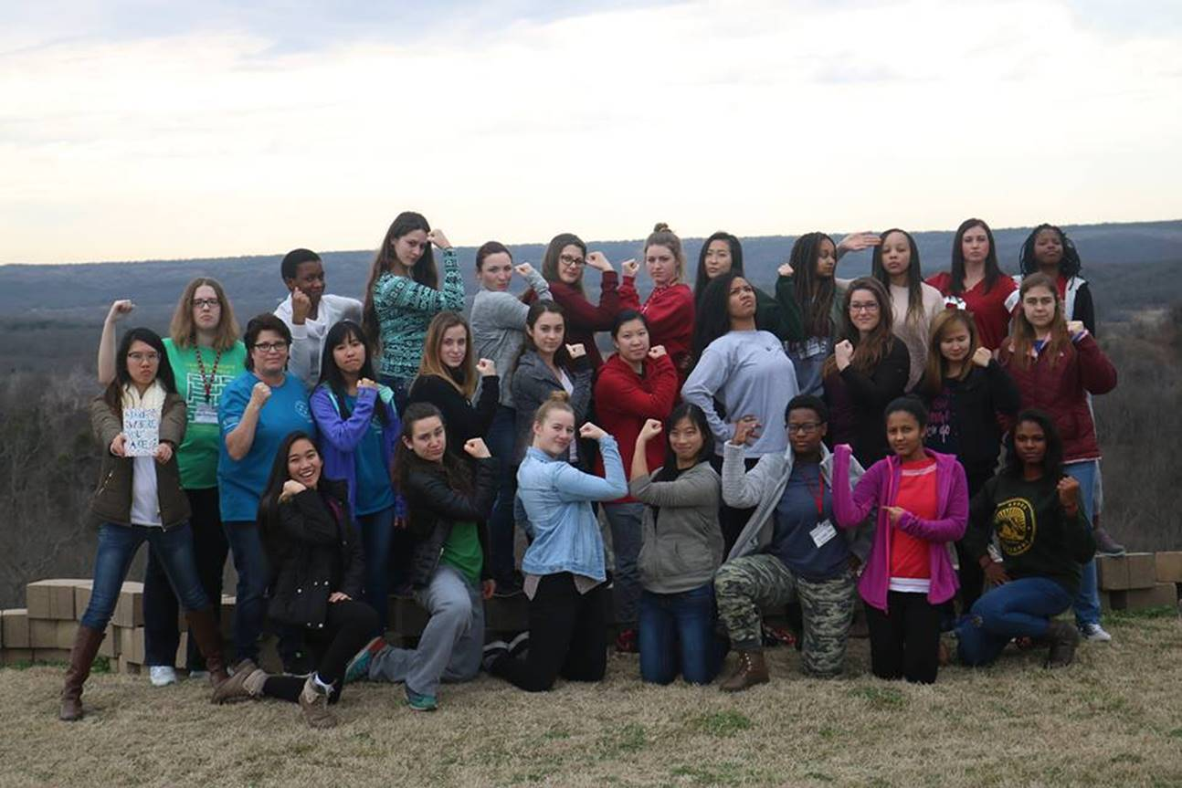

6. The University’s [Halliburton Women's Welcome](https://www.ou.edu/coe/student_life/wie/events/womens-welcome) as the program name indicates is a single-sex, female-only program that provides female students “an opportunity to get a jump start on forming unique connections that will facilitate your success as an engineering or science student.” In answer to the question “WHO?” should attend the University says “All WOMEN.” This event provides many educational benefits that are offered exclusively to women and not available to men including moving into residence halls early, connecting with university and industry personnel, etc. In violation of Title IX this single-sex, female-only program illegally excludes male students based on their sex. The University does not offer an equivalent “Men’s Welcome” event that would fairly and legally accommodate male students with a welcome event that is now offered exclusively for women.

7. The University’s [ONEOK Working Woman Workshop](https://www.ou.edu/coe/student_life/wie/events/oneok-working-woman-workshop) as the program name indicates is a single-sex, female-only program that “provides OU **women engineering students [exclusively]** in the Gallogly and Mewbourne colleges with professional and personal development opportunities that contribute to the preparation of students for career paths in industry and academia.” In violation of Title IX, male students are illegally excluded and discriminated against based on their sex from participating in this program. The University does not offer an equivalent “Working Man Workshop” to legally accommodate male students with the same educational opportunities currently offered exclusively to female students.

8. The University’s [Shell High School Girls Day](https://www.ou.edu/coe/student_life/wie/events/hsgd) as the program name indicates is a single-sex, girl-only no boys allowed program that “provides the opportunity for prospective **high school women** to engage with faculty from various engineering disciplines, and interact with school administration, staff, academic advisors and current students.” In response to WHO should apply, the answer is “Current high school girls in the 9th, 10th, 11th and 12th grade in the spring of this academic year should apply.” This program is held annually in the spring. The University does not offer a male-equivalent program, e.g., “High School Boys Day” that would legally and fairly accommodate high school boys with the same educational opportunities currently offered exclusively for high school females.

9. The University’s [Dorothy Grace Barkow Scholarship](https://www.ou.edu/coe/student_life/wie/scholarships) is a single-sex, female-only scholarship that is awarded annually to five **female students** who attend the Halliburton Women's Welcome. Males are illegally excluded from the Halliburton Women’s Welcome event and also therefore illegally excluded from applying for the Dorothy Grace Barkow Scholarship.

In violation of Title IX, the University’s single-sex, female-only programs above do illegally exclude male students based on their sex, they illegally exclude males based on their sex, and they illegally deny male students from the educational opportunities that are currently available exclusively to female students. Please investigate the University for multiple violations of Title IX’s prohibition of sex discrimination.

Professor Mark J. Perry (email correspondence preferred)